Use Case Example

This Use case is for First Responder Interactive Emergency Navigational Database (FRIEND) [1]

In an incident management system, field officers such as a police officer or a fire fighter, have access to a wireless computer that enables the to interact with a dispatcher. The dispatcher in turn can visualize the current status of all its resources, such as police cars or trucks, on a computer screen and dispatch a resource by issuing commands from a workstation.

In this example, FieldOfficer and Dispatcher are actors. Figure 1 depicts the actor FieldOfficer who invokes the use case ReportEmergency to notify the actor Dispatcher of a new emergency. As a response, the Dispatcher invokes the OpenIncident to create an incident report and orders additional units to the scene with the AllocateResources use case.

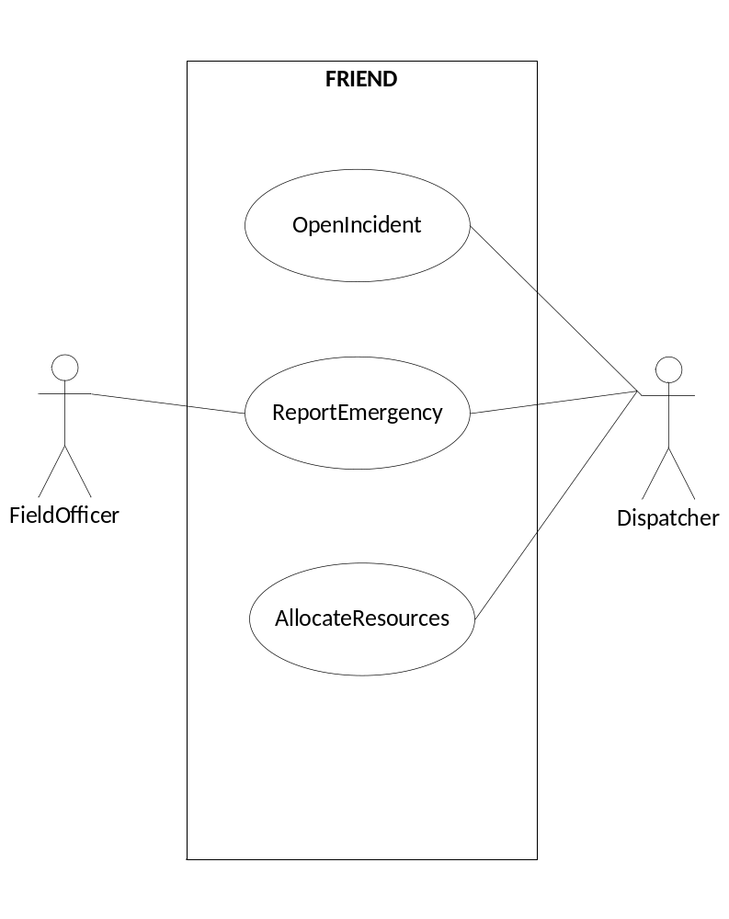

Figure 1: use case diagram for FRIEND

Use case name | ReportEmergency
Participating  actors | Initiated by FieldOfficer  Communicates with Dispatcher
Flow of events | - The FieldOfficer activates the “Repot Emergency” function of her terminal.  - FRIEND responds by presenting a form to the FieldOfficer.  - The FieldOfficer fills out the form by selecting the emergency level, type, location, and brief description of the situation. The FieldOfficer also describes possible responses to the emergency situation. Once the form is completed, the FieldOfficer submits the form.  - FRIEND receives the form and notifies the Dispatcher.  - The Dispatcher reviews the submitted information and creates an Incident in the database by invoking the OpenIncident use case. The Dispatcher selects a response and acknowledges the report.  - FRIEND displays the acknowledgement and the selected response to the FieldOfficer.
Entry condition | - The FieldOfficer is logged into FRIEND.
Exit condition | - The FieldOfficer has received an acknowledgement and the selected response from the Dispatcher, OR  - The FieldOfficer has received an explanation indicating why the transaction could not be processed.
Quality  requirements | - The FieldOfficer’s report is acknowledged within 30 seconds.  - The selected response arrives no later than 30 seconds after it is sent by the Dispatcher.

Figure 2: Use case description for ReportEmergency.

To describe the use case, use the template as shown in Figure 2

- The name of the use case is unique across the system so that developers (and project participants) can unambiguously refer to the use case.
- Participating actors are the actors interacting with the use case.
- Entry conditions describe the conditions that need to be satisfied before the use case is initiated.
- The flow of events describes the sequence of interaction of the use case, which are to be numbered for reference. Organize the flow of events in two columns, the left column representing steps accomplished by the actor, the right column representing steps accomplished by the system. Each pair of actor-system steps represents an interaction.
- Exit conditions describe the conditions that are satisfied after the completion of the use case.
- Quality requirements are requirements that are not related to the functionality of the system. These include the constraints on the performance of the system, its implementation, the hardware platform it runs on, and so on.

Reference:

[1] Bernd Bruegge and Allen Dutoit, “Object Oriented Software Engineering: Using UML, Patterns and Java”, 2nd Edition.

Another Use Case Example

This Use Case is for an Automatic Teller Machine (ATM)

The ATM allows a valid user to perform a set of transactions with their bank account.

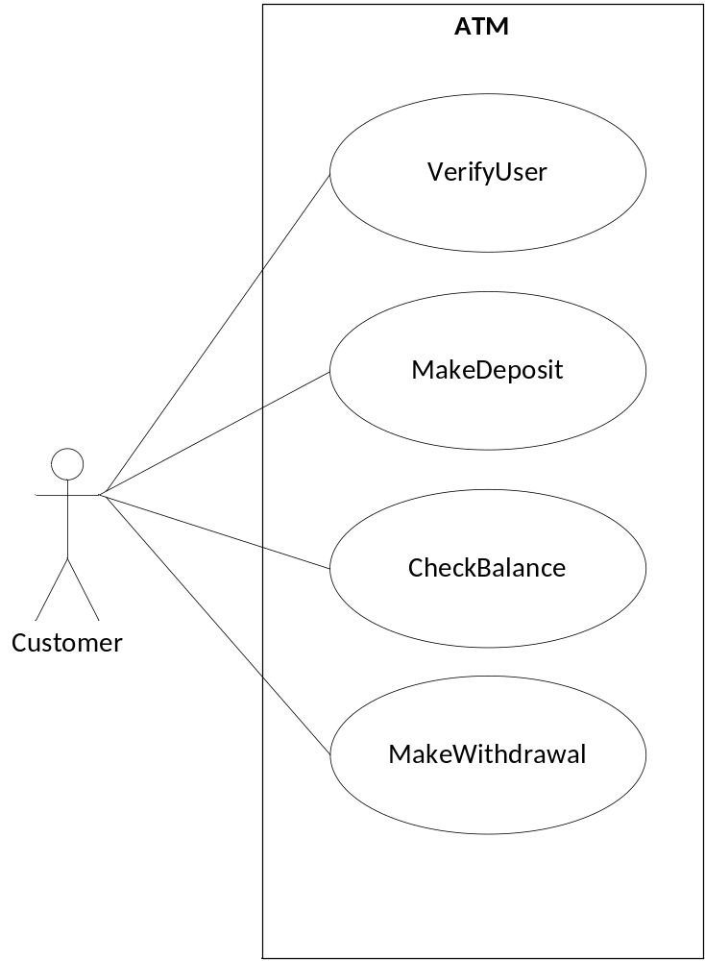

Figure 3: use case diagram for ATM

Use case name | MakeWithdrawal
Participating  actors | Initiated by Customer
Flow of events | - The Customer selects the “Withdrawal” function from the Main Menu.  - ATM responds by presenting an Amount Form to the Customer to enter amount to withdraw.  - The Customer fills out the form by entering withdrawal amount. Once the form is completed, the Customer submits the form.  - ATM displays a message to the Customer to indicate that the transaction is being processed, and verifies that the Customer authorized for the withdrawal.  - The transaction is authorized and ATM displays a message to Customer that cash is being dispensed. ATM dispenses the cash.  - The transaction is not authorized and ATM displays an appropriate message to Customer.  - The Customer confirms the message by selecting the “ok” button.  - ATM displays a message asking the Customer if they want another transaction.  - The Customer makes a selection by indicating “yes” or “no”.  - ATM displays the Main Menu if Customer indicates “yes”. Otherwise ATM ejects card, closes the session and displays the Login Screen.
Entry condition | - The Customer is verified.
Exit condition | - The Customer account is correctly updated.

Figure 4: Use case description for MakeWithdrawal.

